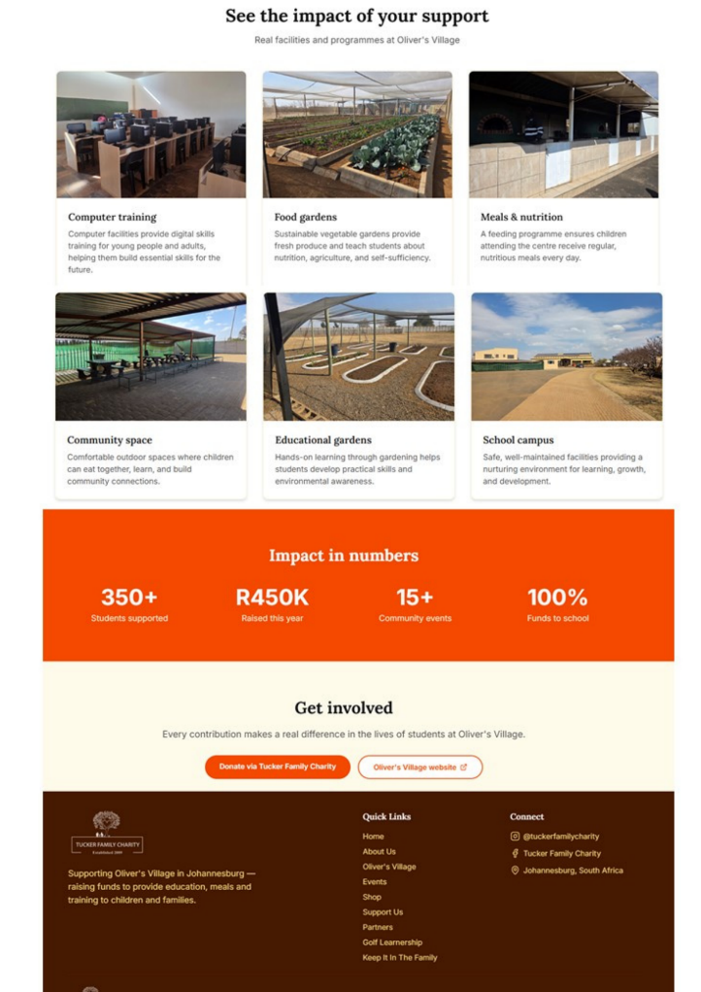
See the impact of your support
Social Service Programmes at Oliver’s Village

PLEASE REPLACE THE ITEMS ABOVE WITH THE FOLLOWING SOCIAL SERVICES.

Early Childhood Development Centre:
The Early Childhood Development Centre at Oliver’s Village nurtures young children with quality care, early learning, and emotional support. By laying a strong foundation for growth and education, it empowers children to reach their full potential from the very start.


Feeding Programme:
Oliver’s Village’s Feeding Programme provides daily nutritious meals to vulnerable children and community members, addressing immediate hunger while supporting health and wellbeing. The programme ensures that beneficiaries have the strength and energy to learn, grow, and thrive.


Computer Training Centre:
Oliver’s Village equips community members with essential digital and internet skills needed to thrive in a modern world. By strengthening communication, supporting entrepreneurship and improving access to employment opportunities.


Agricultural Training College:
Equipping individuals with practical farming skills and hands-on experience in sustainable agriculture. The programme not only supports food security within the community but also empower beneficiaries to build livelihoods with confidence and dignity.
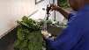

Agricultural Food Gardens:
Oliver’s Village’s Agricultural Food Gardens combined with its Social Enterprise, provide fresh, nutritious produce to the community while creating sustainable livelihoods. The initiative teaches practical farming skills, promotes food security and generates income, empowering beneficiaries to build independence and support their families.
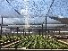

Sustainability-focused:
Operating entirely off solar energy and supported by rainwater harvesting and a borehole system. Its composting, bakery and vegetable gardens supply fresh food to the soup kitchen and Early Childhood Development Centre, creating a thoughtful, eco-conscious system that nourishes both people and community.


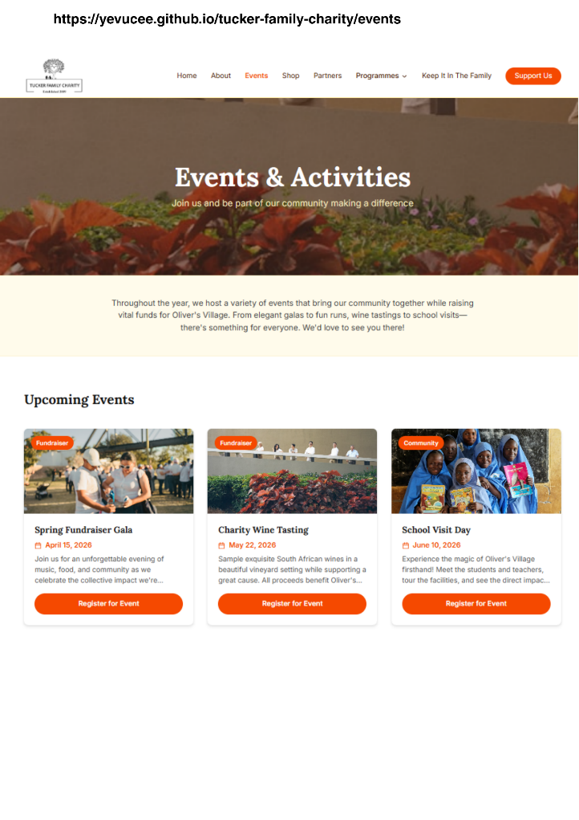
Throughout the year, we host a variety of events that bring our community together while raising vital funds for Oliver’s Village and other initiatives we support.

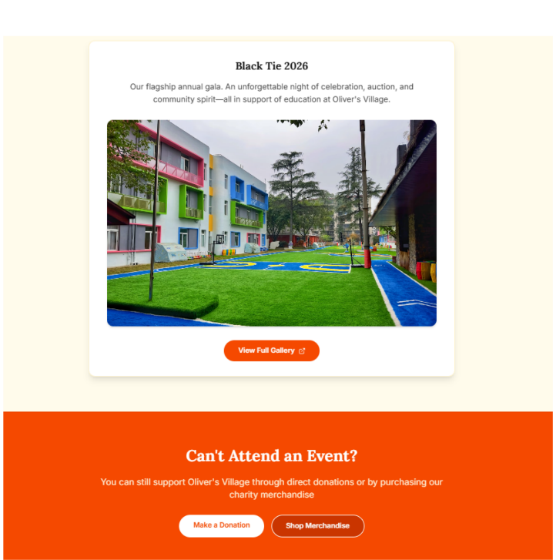
You can still support Tucker Family Charity through direct donations or by purchasing our charity merchandise

